PokeVisualisation – Results interpretations

After the kmeans algorithm splits up pokemons using their statistics, it's possible to see some interesting things. The first analysis is made after using kmeans with 2 classes.

The kmeans launched with only 2 classes can be used to separate good with bad pokemons. For example, the file pokedexKmeans2.json is clearly showing this. The first class contains pokemons like Abra, Bulbizarre, Magicarpe… which are mostly unevolved pokemons. However, the second class contains pokemon like Demolos, Dracaufeu, Ecremeuh, and of course legendary pokemons like Deoxys etc.

Here is a data visualization with Kmeans (2 classes) :
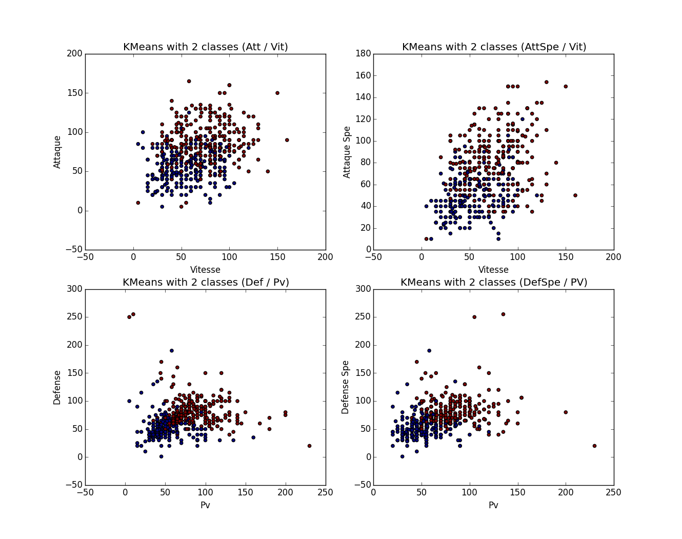
The two first plots are showing sweeper pokemons (pokemons which are focused on attak) and the two others are showing staller pokemons (more defensive pokemons).

In order to have a less global view, a Kmeans with 3 classes is launched. Here are the graphical results :
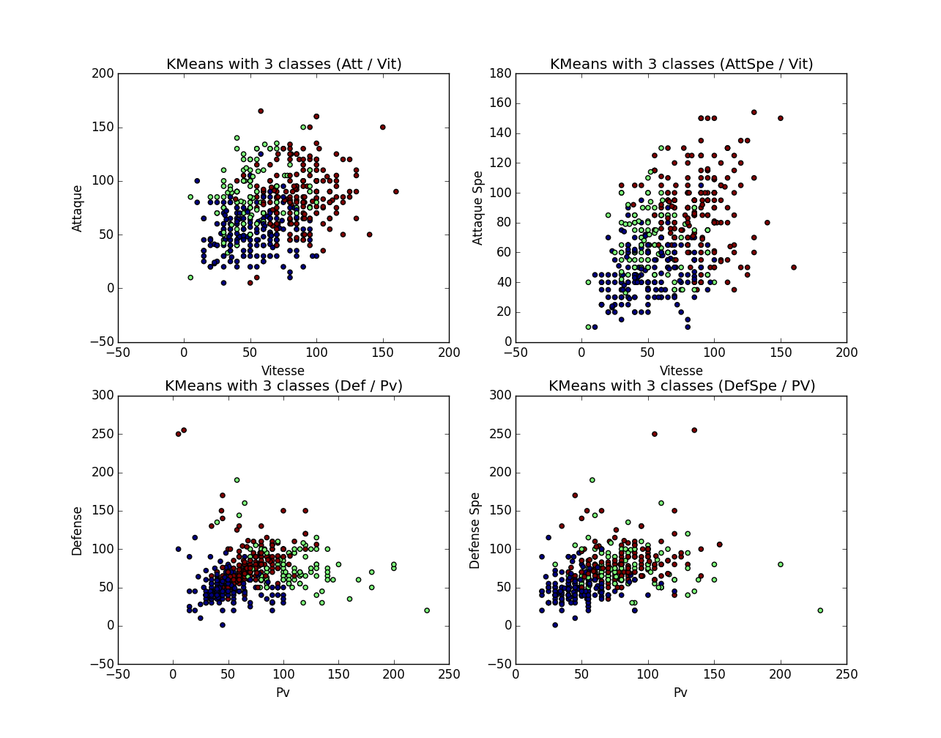
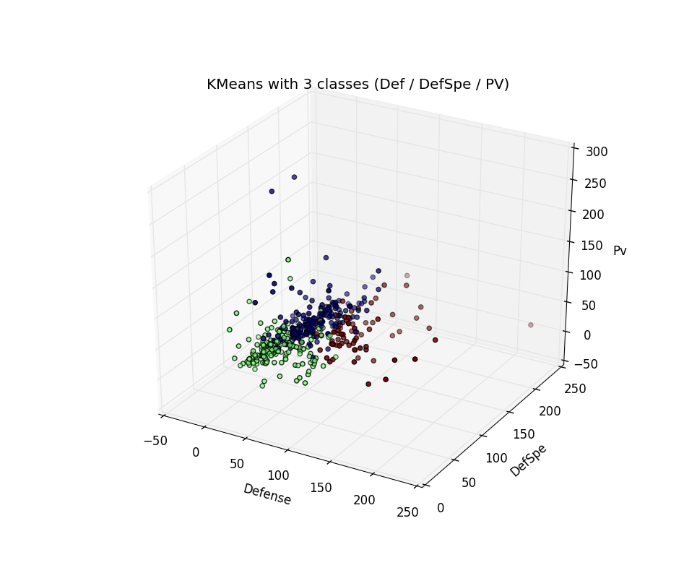
The first thing to note is that concerning sweeper pokemons, there is no utily to have 3 classes. However, for staller pokemons, there is clearly an improvement : it's possible to make a difference between staller more turned with defense / def_spe or with pv. Finally, a 3D-plot is perfectly showing that pokemons have either good defense or good def_spe but hardly both. Even if it's the case, those pokemons don't have many pv.

Finally, the program tests the Kmeans algorithm with 5 classes. Here is the 3D-results :
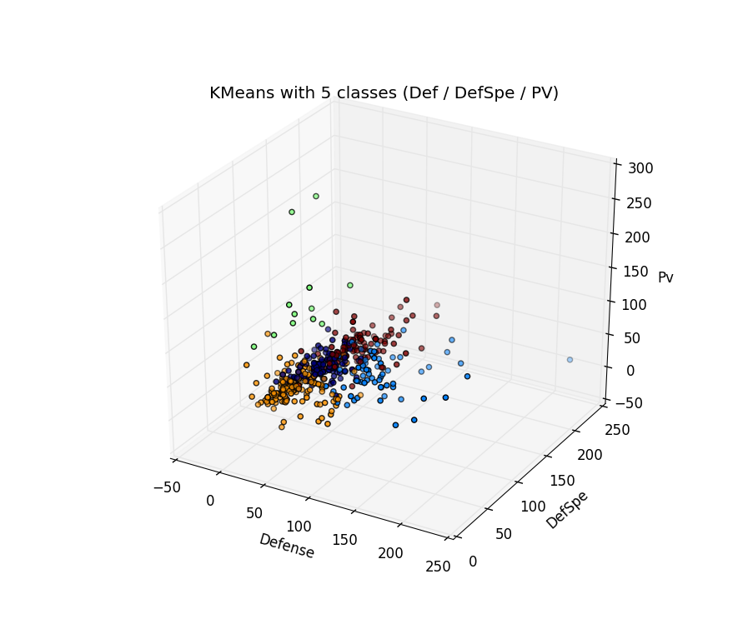
This program class staller pokemons by different tendences :
- Orange : bad staller pokemons with not much Def, Def_spe and pv
Abra, Tentacool, Voltorbe are pokemons in this class
- Green: pokemons with a lot of pv, but compensed by less Def and Def_spe
Leuphorie, Qulbutoke, Ronflex, Roigada are pokemons in this class
- Blue: pokemons with a lot of Def and Def_spe compensed by less pv
Caratroc, Airmure, Galeking, Metalosse are pokemons in this class
- Red: rather pokemons with good pv, def and def_spe
Legendary pokemons mostly
- Black: rather pokemons in the lower mean for staller
Colossinge, Feuforeve, Insecateur, Nostenfer...

